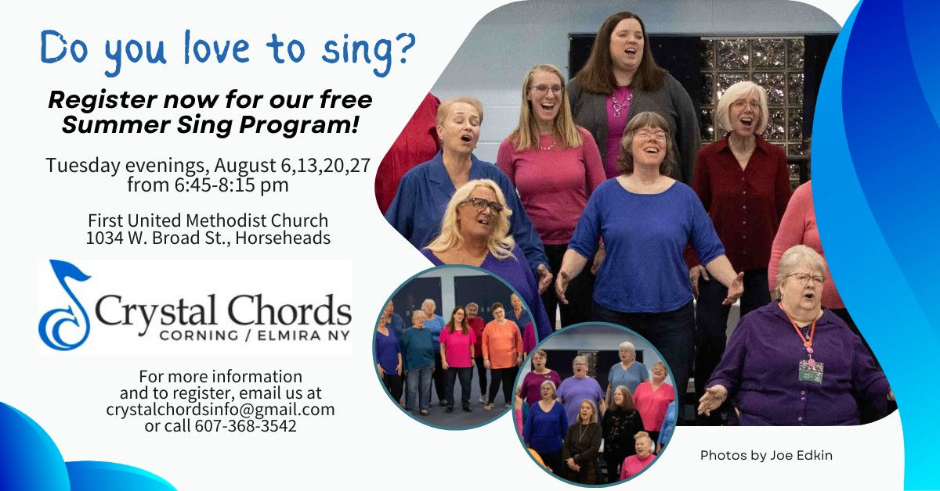

Experience the fun of 4-part a cappella singing!

Crystal Chords Women's A Cappella Chorus invites all women to join us for our Summer Sing program which will be held every Tuesday in August from 6:45 - 8:15 pm. We will learn a new song together…

**"A Thousand Years" by Christina Perri!**

Don't read music? No problem! Learning tracks and sheet music will be provided to you when you register.

Email us today at [crystalchordsinfo@gmail.com](mailto:crystalchordsinfo@gmail.com) to register. We're excited to sing with you this summer!